|  |
| --- |
| **VIPASSANA MANAGEMENT SYSTEM – VIA**  **SEP1 project report** |

**Supervisors:**

Mona Wendel Andersen

Michael Viuff

19 / 12 / 2017

**Version history**

|  |  |  |  |  |  |
| --- | --- | --- | --- | --- | --- |
| Description | Version | Init | Revised | Approved | Date |
| Start of document | 0.1.0 | IHA | <INIT> | <INIT> | 2017-01-31 |
| Small corrections | 0.2.0 | IHA | MWA |  | 2017-02-01 |
| Revisions made in workshop meeting | 1.0.0 | MWA/IHA | All | ICT | 2017-08-19 |

**Group 3**

|  |  |
| --- | --- |
| Student Name | Student No |
| Angel Petrov | 266489 |
| Diyar Hussein | 266352 |
| Rodrigo Pereira | 269084 |
| Rytis Kunigiskis | 266109 |

# Contents

1 Introduction 3

2 Requirements 4

1. Functional Requirements 4

2. Non-Functional Requirements 4

3 Analysis 5

4 Design 9

5 Implementation 13

6 Test 15

7. Results and Discussion 17

8 Conclusion 18

9 Project future 19

10 References 20

11 List of Appendixes 21

**Abstract**

*The objectives of the project are to construct a system for the client company – Vipassana Insight Awareness (VIA) that will perform the requirements that clients request and which will address the way that the company operates and how it works with information management. The technical choices behind constructing the system are that it must follow a set of predefined requirements, must be able to function, given those requirements and must satisfy the needs of the clients. The results of this are a system that not only provides proper functionality, but also, passes almost all testing criteria’s and can be put into use.*

# Introduction

Vipassanā - Insight Awareness (VIA) is a centre for spiritual events originally with a base in the Buddhist principles of meditation as an insight with awareness of what is happening as it happens. They organize spiritual events, send out newsletters and sometimes articles to their members.

Vipassanā does not store any trace of lecturers, members, plans for events, work done by its council or whom they promised advertisements free of charge. This gives the rise of a potential loss of clients which in turn opens a liability in the way that the organisation operates, its potential achievements and overall stability.

Studies have proven that Vipassanã’s meditation is rewarding to the individual - benefits such as improvement of psychological health caused the means to solve the problem in the current situation of Vipassanã, the project will benefit a wide audience of people ***(Szekeres, R. A., and Wertheim, E. H.).*** Furthermore, the end results for an individual who undergoes one of the company’s offered courses yields an increase in positivity, balance, cooperativeness and improvements in mindfulness. ***(Front Psychol)***.

The company has provided key information at the interview in regards to improving their internal data management system and how the company would like to work with and manage information in a way so that it can keep track of members, events, lecturers and work which is done by its council in a simplistic way so that they are able to improve their business strategy prosperity and efficiency whilst addressing their current liability in how the organisation operates.

# Requirements

Requirements concerning system practicality and functionality are as follows:

## Functional Requirements

1. The user should be able to create, modify and remove events within the system.
2. The system should be able to store the customer’s name, phone number, payment year, date of membership and e-mail address.
3. The system should be able to list all events.
4. The system should provide the user the possibility to leave feedback on events on behalf of customers.
5. The user should be able to book events within the system.
6. The system should have a member list that includes name, phone number, date of membership and year of payment, and optionally an e-mail address.
7. The user should be able to search for lecturers and events within the system.
8. The user should be able to search in a specific category within the system.
9. The user should be able to modify member and lecturer information within the system.
10. The user should be able to list all members within the system.
11. The user should be able to add new members and lecturers within the system.
12. The user should be able to finalize events within the system.
13. The system should be able to display feedback from events to sponsors.

## Non-Functional Requirements

# The system needs to answer within 3 seconds 95% of the time.

# The system has to be implemented in Java.

# The system development process must fit in within the customer's budget and needs.

1. The system should be able to read and save to secondary storage based on the Java loose coupling.

# Analysis

* 1. **Use Case Diagram**

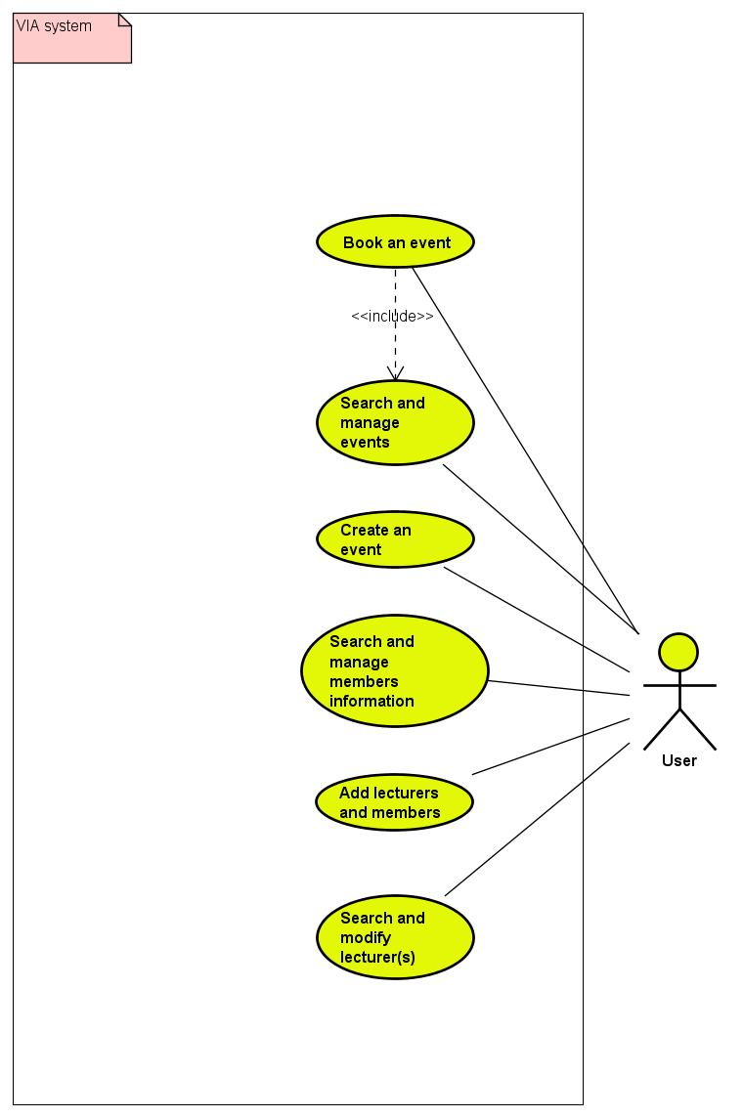

***Figure 1 – Use Case diagram***

The figure above shows the Use Case diagram which represents system functionalities of the program. Within the diagram, the user has the possibility to make use of the corresponding Use Cases. The “User” can be any staff personnel such as “employee” or “staff” that the client company associates with the use of the system.

* 1. **Description of Use Cases**

The description of every Use Case is as follows:

* **Create an event:** For creating a new event and storing it in the system.
* **Add lecturers and members:** For adding lecturers and members to the system.
* **Book an event**: Books an event for a member and stores the booking in the system.
* **Search and manage member information:** for searching and editing information about an existing member in the system.
* **Search and modify lecturers:** for searching and editing information about a specific lecturer in the system.
* **Search and manage events:** Search for events, and manage saved event attributes.
  1. **Activity Diagrams**

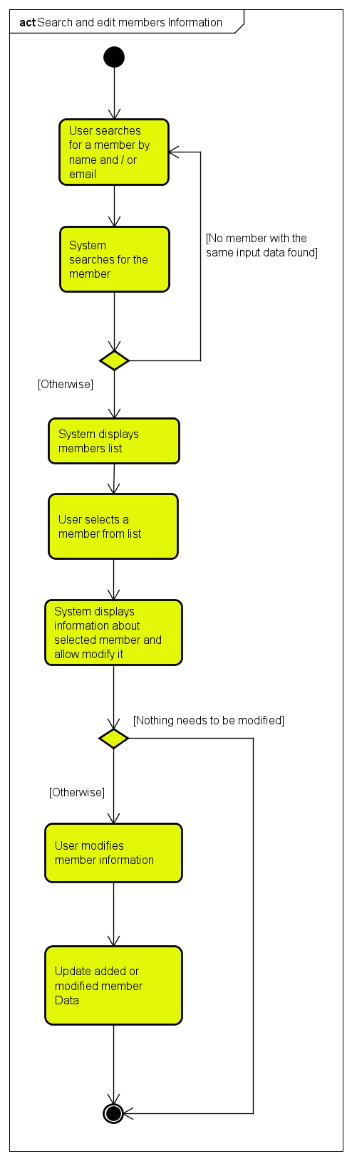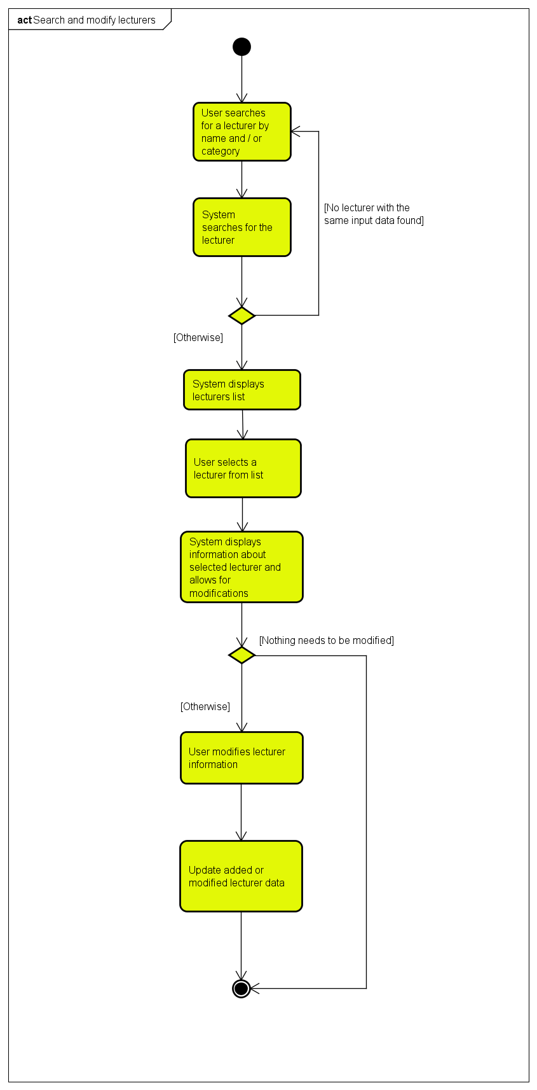

The role of these diagrams is to show the detailed workflow of searching and modifying members and lecturers by the user. The user would be able to search by name for members or lecturers, and can search for lecturers by category and also search for members by email. The system searches for members or lecturers which match found data within that is already within the system. If the system doesn’t find any lecturers or members with the same matching data, the user would have to search again, otherwise the system will display a list of matching results of either members or lecturers. The user will then be able to select a member or lecturer from the list in order to show and / or modify selected member or lecturer. If the user changed any information, the system will update all new information about that lecturer or member.

# Design

* 1. **Class Diagram**

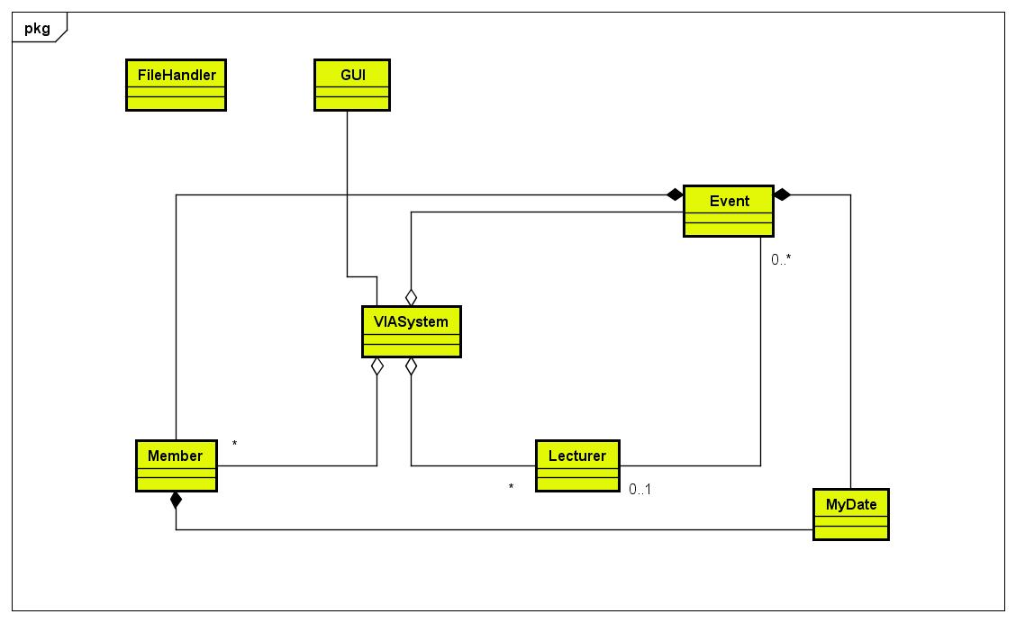

The simplified class diagram above is showing the relationships between the classes. The main part of the program is the VIASystem class which holds all the lists of lecturers, members, events, and all the methods necessary for creating, modifying, and deleting those objects. The event participants are stored in the event class as a list of members. The relationship between events and lecturers is association as all events need to have a lecturer except events of type “Journey”.

The GUI class represents the graphical user interface and the FileHandler class is there to handle files – create and save to them.

* 1. **Sequence Diagram**

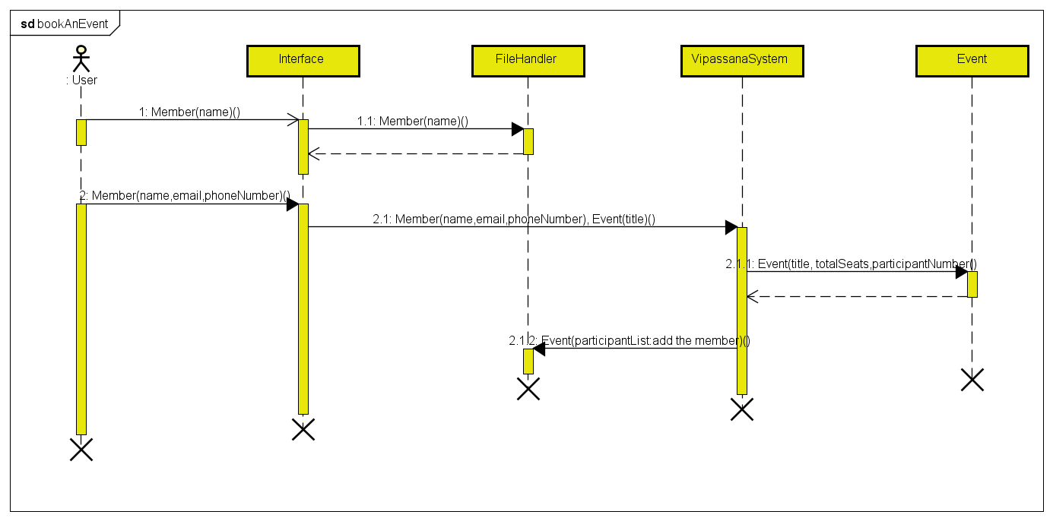

In this sequence diagram, the user books an event for a member. He needs to first search for the member by name. The name will then be searched within the system storage system (members file) and the interface will show a list of matching results (if any are found). The user can then select the member who wants to book the event. When he does, a message with that specific member and the wanted event (already chosen) being sent to the main class VipassanaSystem, which sends a message to the Event class in order to make sure that the event is finalized and not sold out (number of participants is less than total seats). Finally, the chosen member should be added to the event participants list and saved to the event file.

* 1. **GUI**

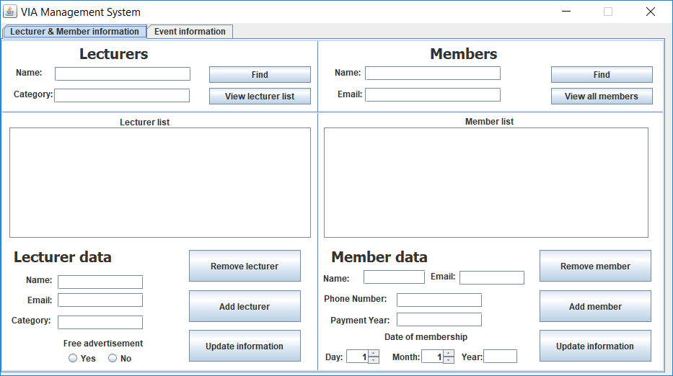

The GUI was developed using Window Builder. The main window is simple and consists of two tabs, the first is called “Lecturers and members information” and it allows adding and removing new members and lecturers, as well as searching for a specific one and editing or removing them.

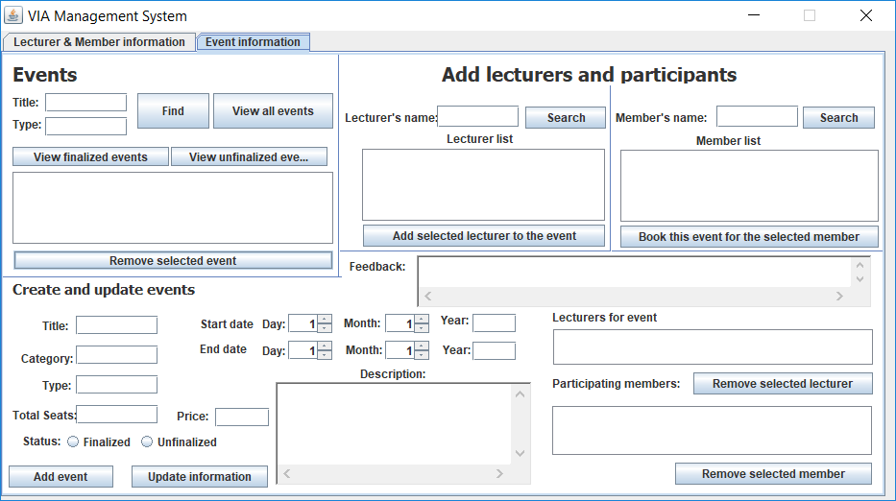

The other tab is called “Event information”. It allows the user to easily create a new event (either finalized or not), find events to edit, search for lecturers to add to the event, and search for members to add to the participants list of the chosen event. However, the event must be finalized to add members to its participants list, and some fields are not mandatory to fill in when creating a new event if it is unfinalized.

# Implementation

The following code shows one of the most important functions in the system, which is adding a member to the participants list of an event:

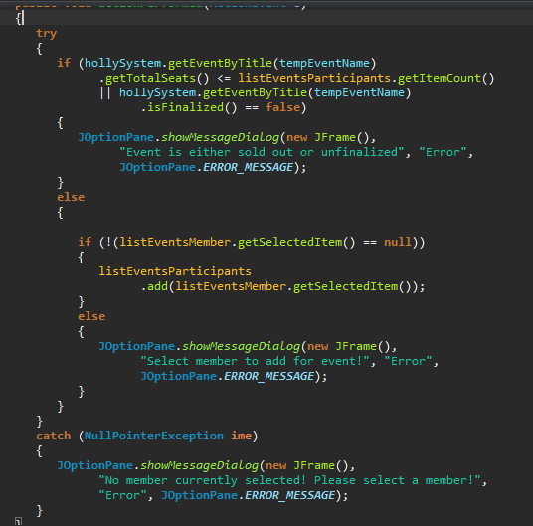

A member needs to be searched and selected from the list before adding them to the list (NullPointerException is cought). If the selected event has total seats less or equal to the number of participants, or the selected event is not finalized, the system shows an error message, otherwise, the system adds the selected member to the participants list of the event.

Another important function in the system is Creating an event. The status must be defined when creating every new event (must be either finalized or unfinalized).

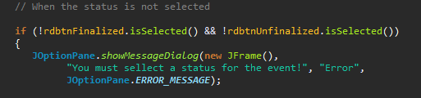

When the event is finalized, the system checks if all required fields are filled in correctly as shown below, and then starts creating the new event. However, not all fields are mandatory to fill in when creating an unfinalized event.

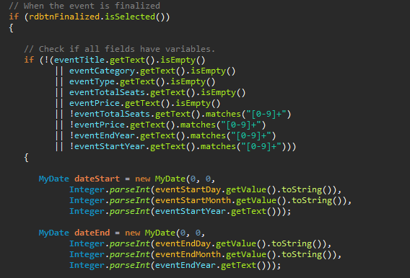

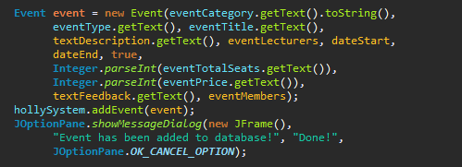

# Test

* 1. **Core functionality:**

|  |  |  |
| --- | --- | --- |
| # | Functionality description | Status |
| 1 | GUI window displays upon runtime of application | Working |
| 2 | System creates new storage files if previous ones are not found | Working |
| 3 | Data persistence is consistent on program runtime | Working |
| 4 | Window size and window elements are resizable in full screen | Not implemented |
| 5 | Usage of separate JFrame windows for given sections of system | Not implemented |
| 6 | Invalid data input safeguards | Working |
| 7 | Program works with full date information | Partly-implemented |

* 1. **“Lecturer and Member information” tab:**

|  |  |  |
| --- | --- | --- |
| # | Functionality description | Status |
| 1 | Reading member and lecturer information from storage system | Working |
| 2 | Writing member and lecturer information to storage system | Working |
| 3 | Adding a member / lecturer | Working |
| 4 | Finding a member / lecturer | Working |
| 5 | View of all members / lecturers | Working |
| 6 | Removing a member / lecturer | Working |
| 7 | Modifying current member / lecturer information | Working |
| 8 | Displaying member / lecturer list | Working |

* 1. **“Event information” tab:**

|  |  |  |
| --- | --- | --- |
| # | Functionality description | Status |
| 1 | Reading event information from storage system | Working |
| 2 | Writing event information to storage system | Working |
| 3 | Adding an event | Working |
| 4 | View all events | Working |
| 5 | View finalized events | Working |
| 6 | View unfinalized events | Working |
| 7 | Search for matching member / lecturer within storage system | Working |
| 8 | Association of member / lecturer to event | Working |
| 9 | Updating / removing an event | Working |
| 10 | Member event preferences | Not implemented |
| 11 | Member emailing system | Not implemented |

* **Conclusion:**

Critical functionality has been implemented and program functionality is normal. File persistence is utilized by the system on every runtime – saving and reading data, data differentiation, information reading and input collection.

# Results and Discussion

The system is implemented properly with all necessary features to handle files and do the job covering for all important requirements.

# Conclusion

The system covers all necessary functionality and is in compliance with requested requirements by which it is almost completely functional to use by the end user.

The program makes use of event date setting, however, it cannot make use of whole time saving as this feature is partly implemented. In essence, the user is unable to specify a given hour and minute for any event that they add or modify.

|  |  |  |
| --- | --- | --- |
| # | Program functionality description | Status |
| 1 | The user should be able to create, modify and remove events within the system. | Fulfilled |
| 2 | The system should be able to store the customer’s name, phone number, payment year, date of membership and e-mail address. | Fulfilled |
| 3 | The system should be able to list all events. | Fulfilled |
| 4 | The system should provide the user the possibility to leave feedback on events on behalf of customers. | Fulfilled |
| 5 | The user should be able to book events within the system. | Fulfilled |
| 6 | The system should have a member list that includes name, phone number, date of membership and year of payment, and optionally an e-mail address. | Fulfilled |
| 7 | The user should be able to search for lecturers and events within the system. | Fulfilled |
| 8 | The user should be able to search in a specific category within the system. | Fulfilled |
| 9 | The user should be able to modify member and lecturer information within the system. | Fulfilled |
| 10 | The user should be able to list all members within the system. | Fulfilled |
| 11 | The user should be able to add new members and lecturers within the system. | Fulfilled |
| 12 | The user should be able to finalize events within the system. | Fulfilled |
| 13 | The user should be able to leave feedback on a selected event. | Fulfilled |

All requirements that were defined have been fulfilled within this project.

# Project future

Changes to the project in the future can include code optimization – better structuring, avoidance of code clutter, extension of java classes and division of parent classes.

**New features:**

The system implementation would benefit from a better GUI and as such, making use of the JavaFX library would be the best for how GUI design would be better. This, in combination with tables, is a much better choice instead of relying on Swing for handling the interface.

Multiple selection of members and lecturers for adding to an event can also be added so that the user can choose from more than one member at a time.

An email messaging system would also be a positive addition to the program by which the user can select members and send information about the event to them.

# References

Roberta A. Szekeres, Eleanor H. Wertheim. 2014. Evaluation of Vipassana Meditation Course Effects on Subjective Stress, Well-being, Self-kindness and Mindfulness in a Community Sample: Post-course and 6-month Outcomes. [online]

Available at: <http://onlinelibrary.wiley.com.ez-aaa.statsbiblioteket.dk:2048/doi/10.1002/smi.2562/full>

Front Psychol. 2016. Psychological Effects of a 1-Month Meditation Retreat on Experienced Meditators: The Role of Non-attachment. [online]

Available at: <https://www.ncbi.nlm.nih.gov/pmc/articles/PMC5149565/>

# List of Appendixes

* Project Description
* User Guide
* Design class diagram

**Original Project Description**

**Vipassanā – Insight Awareness (VIA)**

**Students**

**Angel Petrov - 266489**

**Rytis Kunigiskis - 266109**

**Diyar Hussein - 266352**

**Rodrigo Pereira - 269084**

**Supervisors**

**Mona Wendel Andersen**

**Michael Vuff**

**ICT Engineering**

**1st Semester**

**02/10/2017**

**Table of content**

1 Background description 24

2 Definition of purpose 25

3 Problem Statement 26

4 Delimitation 27

5 Choice of models and methods 28

6 Time schedule 29

7 Risk assessment 30

8 Sources of Information 31

9 Appendices (including Group Contract) 31

# Background description

Vipassanā - Insight Awareness (VIA) is a centre for spiritual events originally with a base in the Buddhist principles of meditation as an insight with awareness of what is happening as it happens. They organize spiritual events, send out newsletters and sometimes articles to their members.

Vipassanā does not store any trace of lecturers, members, plans for events, work done by its council or whom they promised advertisements free of charge. This gives the rise of potential loss of clients which in turn opens a liability in the way that the organisation operates, its potential achievements and overall stability. Studies have proven that Vipassanã’s meditation is rewarding to the individual - benefits such as improvement of psychological health caused the means to solve the problem of current situation of Vipassanã, the project will benefit the wide audience of people. Furthermore, there are sources which claim that Vipassanã’s practices yield a more prosperous way of living as a conclusion from studies on a wide range of audiences who have been exposed to meditation courses with a wide variety of time spans. It can be concluded that stress management is an important area of concern and it should be taken care off because it is not only beneficial for the organization but at the same time it also improves individual life of employees. The following diagram shows the outcomes on people which have been subjected to a meditation course lasting six months.

**Evaluation of *Vipassanā* Meditation Course Effects on Subjective Stress, Well‐being, Self‐kindness and Mindfulness in a**

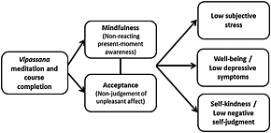

**Community Sample: Post‐course and 6‐.month Outcomes**

“**Sometimes a single Vipassana course can give someone enough direct experience of the truth inside that for them the path is clear: “This is where I want to go. This is what I want to be.” For others it takes longer.**” - Independent Publishers Group I.H 2003 9781928706212

The quote above represents the thoughts of a person who has underwent the Vipassanā course clearly pointing out that a person’s perspective changes.

# Definition of purpose

The definition of purpose for this project is to construct a system that has the ability to keep track of records which will allow Vipassana to improve its data management.

# Problem Statement

Overall problem:

The current and future problems that the group will encounter along the way will be the lack of information that the system will process, the necessary automation methods - if, for example, a specific part of people need to be selected or contacted - what would be a necessary pre-requirement for the system to go into effect.

**The questions regarding the problem statement are the following:**

Q: How will the backend of the system tie with the GUI (Graphical User Interface) and what possibilities will the system have for the GUI to offer?

The possibilities of the system and the GUI structure need to be appropriate with one another for there to be a consistent logic in the systems’ possibilities. Some of the possibilities are still unknown and some may likely change as the project moves forward.

Q: How will the system know who is going to have higher privileges than the other? The system will need to differentiate between a user and a company representative so that both have easy access

Q: How can the system store the different events and members with all of their personalized information?

Based on the actual collected information, the system needs to meet three different criterias - information handling, events handling and categorization of the said personalized user information.

Q: How can the user search for lecturers in a given category?

A good and easy-to-use user interface is a very important part in every application and system. Therefore the group should spend some time to insure an easy user experience with a good search engine.

# Delimitation

The system and the project are aimed towards the software market and are in turn developed for the clients who have requested such a service to be created - Vipassanā - Insight Awareness.

What the assigned group will firmly focus on are the technical problems, For example, how to make the system better. Otherwise, there will not be focus on problems such as searching for the most wished lectures and events.

Another thing that the group will not focus on is a good looking user interface, as the group will focus on adding key functionality to the systems’ abilities.

# Choice of models and methods

**Internal group event handling:**

The project’s strategy of overcoming potential problems will have a direct impact on its outcomes. The aim is to gain a solid knowledge base for the team that is working on the assigned project and focus that gained knowledge whilst researching problems which will be encountered during its development. The focus in this project is going to be on creating all assets, testing and finalizing the working system - in other words words: events handling. This is a critical aspect of project management as well as workflow management. Keeping track of progress of the workflow is vital as it yields a better perception of the overall outcome. The methodology behind this will be to have group work as well as individual handling of work and / or upcoming project events. The responsibility of the events handling, time planning, and workload distribution will be assigned to Angel Petrov which will in turn plan ahead of time and see through upcoming tasks and solve any obstacles related to the group work distribution.

**System readability and management:**

Another partial problem is making the system as easy to understand as possible so that the end users don’t have any problems such as encountering bugs or compatibility issues. Managing code is also within this category - adding comments for “what goes where” or “what this thing does” is a good way of understanding things that fellow colleagues have implemented, however not first priority. A better outcome is expected as others are going to have a better understanding of what the person who implemented that specific area of the project actually meant and if they see the need, they will have a better idea of how to improve that specific area. The main person who will be responsible for this area will be Rytis Kunigiskis, however everyone will assume this role to a certain extent but the responsible person for this area will have a focus on going through all the code. This said person will have the opportunity to go through all of the code and discuss what is right or wrong and propose to add or remove specific parts from the structure of the system. A rough estimated workload for this part will be around 10 percent or 55 hours of the overall workload of 550 hours but overall the timing will solely rely on which parts of the project are currently being evaluated, their length and meaning within the project (some parts do not need to be explained, others do).

**Finding sponsors for newsletters:**

The system will not only store sponsors that have been sponsoring Vipassana successfully before, but also will allow to maintain the list, add new sponsors or delete the old ones and add or edit the description of each sponsor. It will allow the customer to keep track of their sponsors and quickly get information about them, give them feedback about the sponsors for the categories that they show interest in. Diyar Hussein will take responsibility for this point and estimated workload for this point should be around 5 hours or around 5 percent of the overall workload.

**Finding non-finalized events to finalize them:**

Planning events requires a lot of information and quick access to it with a good search engine will provide fast planning to finalize all non-finalized events. The user will be able to review the status of any event and see all required details about it. Rodrigo Pereira will hold responsibility for this point. Estimated time for fulfilling this task should be around 83 hours or around 15 percent.

**Storing needed data for the system:**

Data will be stored locally. This will ensure data protection. Everyone in the group is responsible for this point. Estimated work hours around 25 hours or 5 percent.

# Time schedule

Our group will work on the project based on the [Waterfall](https://en.wikipedia.org/wiki/Waterfall_model) model which will in turn yield a progressive style of software development throughout the different project stages as opposed to using models such as, for example, [SCRUM](https://en.wikipedia.org/wiki/Scrum_(software_development)) or [Kanban](https://en.wikipedia.org/wiki/Kanban).

The following table represents the assigned group’s workload and work span in a given category based on the Waterfall model: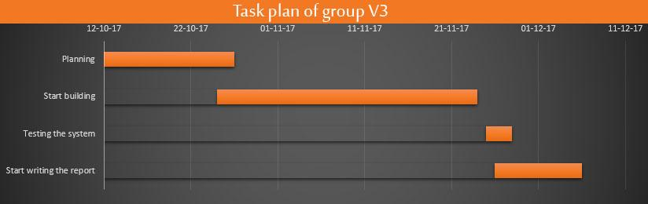

# Risk assessment

|  |  |  |  |  |  |  |
| --- | --- | --- | --- | --- | --- | --- |
| Risks | Description | Likelihood | Severity | Risk mitigation | Identifiers | Responsible |
| Running out of time | Time management is a necessity | 3 | 4 | Work in the specified work time and plan | Coming up project deadline, stalling | Group 3 |
| No knowledge of how to perform some project parts | To get the best out of the system, knowledge has to be well collected | 2 | 3 | Research and ask questions | No initial planning | Group 3 |
| Project team instability | Team stability is a key factor to success and vise versa | 4 | 5 | Insure individual member well-being | Member absence, uncertainty, unreliability | Group 3 |
| Infringement on third party sources | Relying on proprietary content for “inspiration” | 1 | 3 | Avoid at all costs | External code used that is guarded by a proprietary license | Group 3 |

# Sources of Information

Background description:

* [Source № 1](http://onlinelibrary.wiley.com.ez-aaa.statsbiblioteket.dk:2048/doi/10.1002/smi.2562/full) (login required)
* [Source № 2](https://www.ncbi.nlm.nih.gov/pmc/articles/PMC5149565/)
* [Source № 3](http://ijaiem.org/volume3issue1/IJAIEM-2014-01-30-081.pdf)
* [Source № 4](http://web.a.ebscohost.com.ez-aaa.statsbiblioteket.dk:2048/ehost/ebookviewer/ebook/bmxlYmtfXzQxNDEzNF9fQU41?sid=5a2026ce-749b-40aa-8d4d-cc27513085bf@sessionmgr4007&vid=0&format=EB&rid=1) (login required) - [alternative link](https://books.google.dk/books?id=h1Q9BQAAQBAJ&pg=PT90&lpg=PT90&dq=Sometimes%20a%20single%20Vipassana%20course%20can%20give%20someone%20enough%20direct%20experience%20of%20the%20truth%20inside%20that%20for%20them%20the%20path%20is%20clear%3A%20%E2%80%9CThis%20is%20where%20I%20want%20to%20go.%20This%20is%20what%20I%20want%20to%20be.%E2%80%9D%20For%20others%20it%20takes%20longer&source=bl&ots=rjehF_oCFO&sig=WgslXGxx7NXXkN-NFco9Aqk3nbA&hl=en&sa=X&ved=0ahUKEwjAwPuv9ObWAhWkC5oKHRX1AN8Q6AEIJjAA#v=onepage&q&f=false)

|  |
| --- |
| **VIPASSANA MANAGEMENT SYSTEM - VIA**  **User Guide** |

**Supervisors:**

Mona Wendel Andersen

Michael Viuff

19 / 12 / 2017

**Group 3**

|  |  |
| --- | --- |
| **Student Name** | **Student No** |
| Angel Petrov | 266489 |
| Rytis Kunigiskis | 266109 |
| Rodrigo Pereira | 269084 |
| Diyar Hussein | 266352 |

**Preface:**

The following user guide gives a step by step explanation to

correctly utilize all features of the system.



**WARNING:**

Before you start using this software, please, read the following information carefully:

**Runtime requirements:**

This program makes use of the Java Runtime Environment by

software developer Oracle which is necessary in order for the program to operate correctly. You can find this software at oracle.com/downloads.

**Program functionality:**

This program makes use of an additional data storage system  
which reads and writes additional files for the program to function  
properly.



**Trademark information:**The Java Runtime Environment and Java are trademarks of

Sun Microsystems, Inc. in the U.S. and certain other countries.

**Table of contents:**

Overview of program…………………………………………....4

Lecturer & Member information……………...…………………5

Members………….…………………………….......…………...6

Lecturer data…………………………………………...……....10

Lecturers……………………………………………………….11

Event Information……………………………………………...15

Sections of Event information………………………………….16

Create and update events…………………………………….....17

Events………………………………………………………….18

Add lecturers and participants………………………………….20

1. **Overview of the program:**



**Description:**

This is the start screen for the program. The main tab of the program is entitled “**Lecturer & Member information**” and contains four sections: “**Member data**”, “**Members**”, “**Lecturer** **data**”, and “**Lecturers**”.

1. 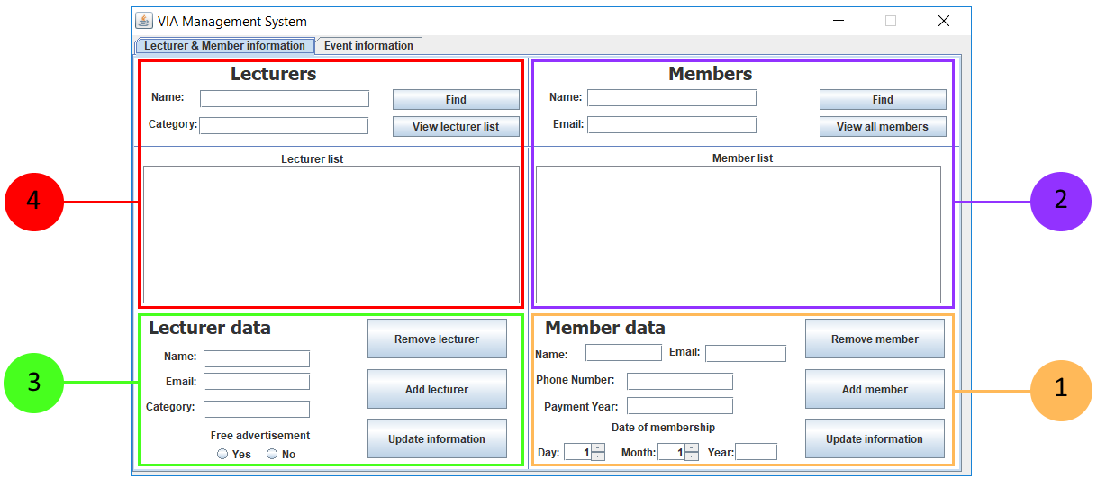 **Lecturer & Member information:**
2.  **Member data:**

Within the member section, you are able to add new members, modify existing information and remove a member.

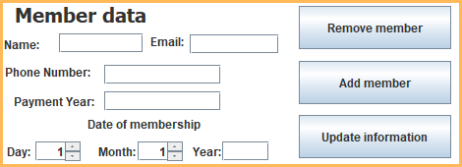

**To add a member:**

1. Fill the name field with the member’s information;
2. Fill the email field with the member’s information;
3. Fill the phone number field with the information provided by the customer;
4. Write the payment year in the payment year field;
5. Select the date of membership for the member which includes day, month and year;
6. Press the “Add member” button to store the member’s information.

Upon successful input of information, you will be presented with the following message:

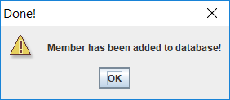

Information about the member has now been stored and you may close this window.

1.  **Members:**

To find, remove or update an existing member, you will need to have added that member first before being able to modify member information. You are able to find a member by either name or email.

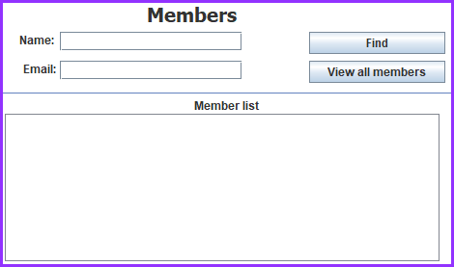

**To find a member:**

1. Enter relevant search information about the member in the name field (Optional if step b has been done);
2. Enter email address of member in the email field (Optional if step a has been done);
3. Click on the “Find” button;

Upon successful search, you will be presented with the desired member in the member list:

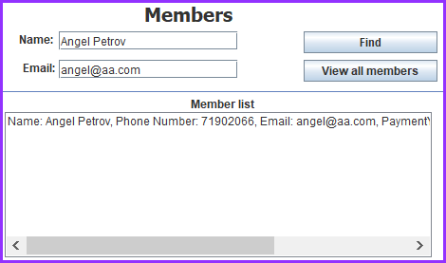

**Viewing all members:**

1. Click on the “View all members” button;
2. The program will show all available members that have been added to the program, prior to viewing all members:

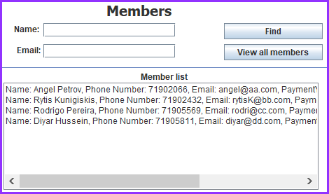

**Removing a member from the member list:**

1. Select a member that you wish to remove from the member list;
2. In the “Members data” section, click on the “Remove member” button:

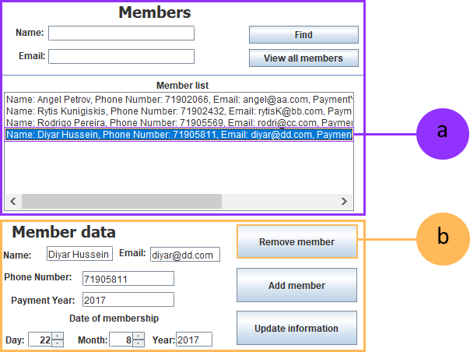

Upon successful deletion of a member, you will be presented with the following message:

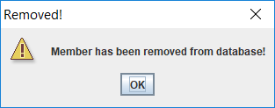

Information about the member has now been updated and you may close this window.

**Updating information about member:**

1. Select a member that you wish to update information about from the member list and edit any desired information about the member;
2. Click on the “Update information” button to save updated information.

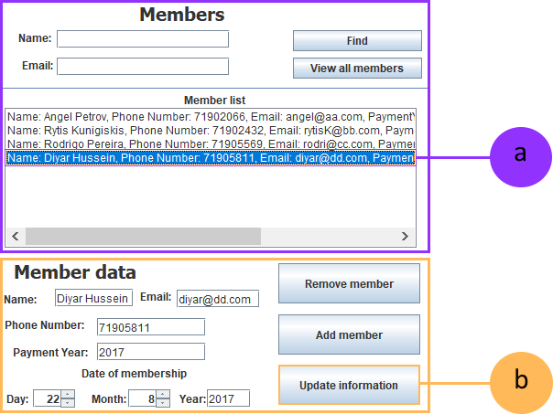

Upon successful update of a member information, you will be presented with the following message:

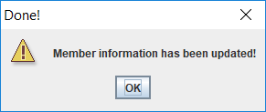

Information about the member has now been updated and you may close this window.

1.  **Lecturer data:**

Within the lecturers section, you are able to add new lecturers, modify existing information and remove a lecturer.

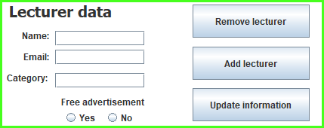

**To add a lecturer:**

1. Fill the name field with the lecturer’s information;
2. Fill the email field with the lecturer’s information;
3. Write the category that the lecturer will be in;
4. Write the payment year in the payment year field;
5. Select the date of membership for the member which includes day, month and year;
6. Press the “Add member” button to store the member’s information.

Upon successful input of information, you will be presented with the following message:



Information about the member has now been stored and you may close this window.

1.  **Lecturers:**

To find, remove or update an existing lecturer, you will need to have added that lecturer first before being able to modify lecturer information. You are able to find a lecturer by either name or category.

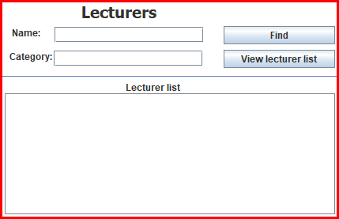

**To find a lecturer:**

1. Enter relevant search information about the lecturer in the name field (Optional if step b has been done);
2. Enter email address of member in the email field (Optional if step a has been done);
3. Click on the “Find” button;

Upon successful search, you will be presented with the desired lecturer in the lecturer list:

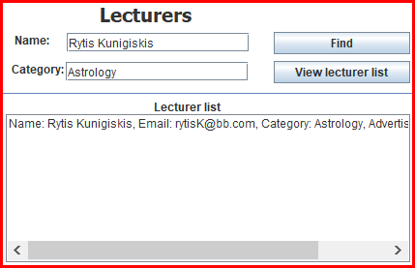

**Viewing all lecturers:**

1. Click on the “View lecturer list” button;
2. The program will show all available lecturers that have been added to the program, prior to viewing all lectures:

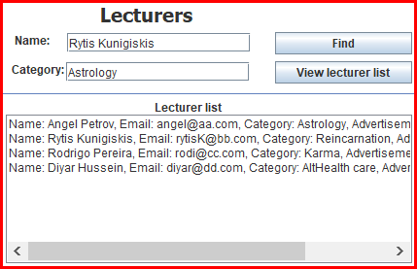

**Removing a lecturer from the member list:**

1. Select a lecturer that you wish to remove from the lecture list;
2. In the “Lecturer data” section, click on the “Remove lecturer” button:

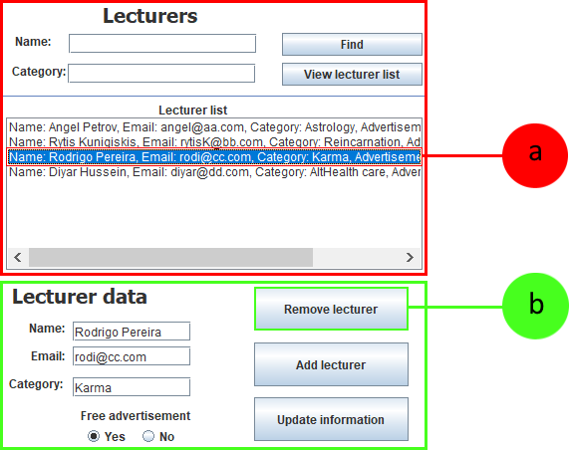

**Updating information about lecturer:**

1. Select a lecturer that you wish to update information about from the lecturer list and edit any desired information about the lecturer;
2. Click on the “Update information” button to save updated information.

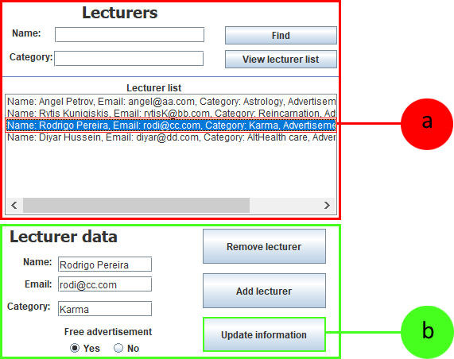

Upon successful update of a member information, you will be presented with the following message:

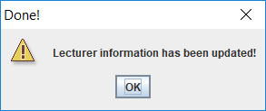

Information about the lecturer has now been updated and you may close this window.

1. ** Event Information:**

**Description:**

The illustration above is and overview of the event tab which contains three sections: “**Create and update events**”, “**Events**” and “**Add lecturers and participants**”.

1. 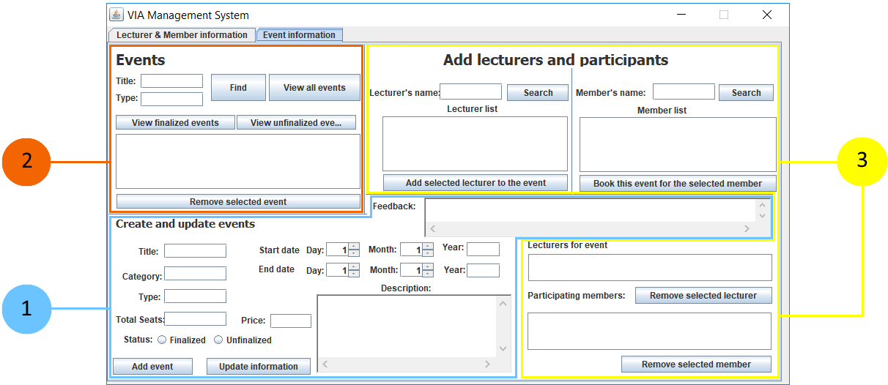 **Sections of Event information:**
2. **Create and update events:**

In the create and update events section, you are able add information for an event, its starting and ending time, a description for the event and leave feedback.

**Creating an event:**

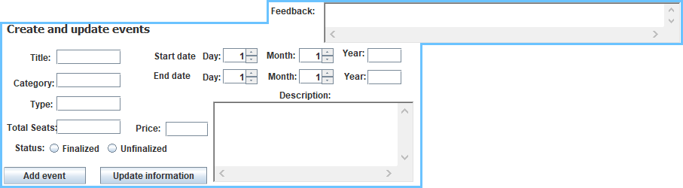



1. Fill the tittle field with the title of the event;
2. Write in which category the event is within the category field;
3. Specify the type of event in the type field;
4. Fill the total seats for the event in the total seats field;
5. Specify the price for the event in the price field;
6. Choose one of the available buttons - “Finalized” or “Unfocalized” depending on event status;
7. Select the start day, month and fill in the year field with the event start date;
8. Select the end day, month and fill in the year field with the event end date;
9. Optionally, give a description for the given event in the “Description” field;
10. Optionally, leave feedback for the given event in the “Feedback” field;
11. Press the “Add event” button to save event information;

Upon successful input of information, you will be presented with the following message:

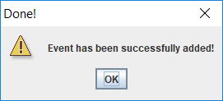

Information about the lecturer has now been updated and you may close this window.

1. **Events**

In the events section, you are able to find events by either

title, type or both.

**Finding an event:**

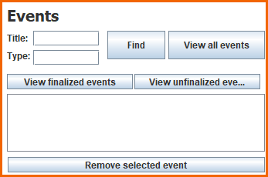

1. Enter the title of the event that you would like to find in the title field (Optional if step b has been done);
2. Enter the type of the event that you would like to find in the type field (Optional if step a has been done);
3. Click on the “Find” button to find events based on the search preferences that you provided.

Upon successful search, you will be presented with the desired lecturer in the lecturer list:

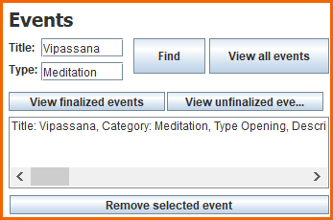

1. To get a list of all events that have been added, click on the button “View all events”;
2. To get a list of events that have been finalized, click on the button “View finalized events”;
3. To get a list of events that have not been finalized yet, click on the button “View unfinalized events”.

**Editing event information:**

1. Select an event that you wish to update information about from the events section;
2. Click on the “Update information” button to save updated information.

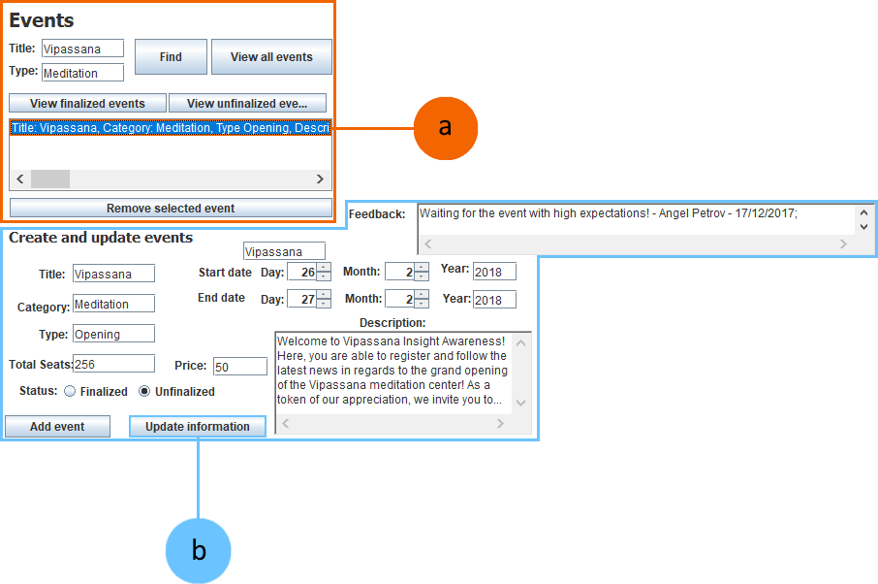

Upon successful input of information, you will be presented with the following message:

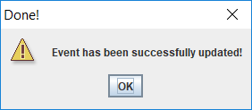

Information about the lecturer has now been updated and you may close this window.

1. **Add lecturers and participants:**

The lecturers and participants section provides the possibility to add lectures and participants for a selected event that have already been added under the “Lecturer & Member information” in the sections “Lecturer data” and “Member data”.

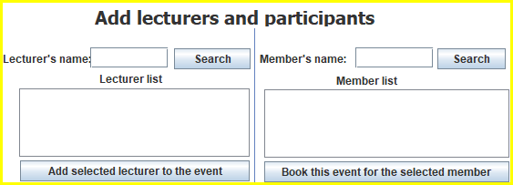

**Searching for lecturers:**

1. Fill in the lecturer’s name in the designated field;
2. Press the “Search” button to search with the given criteria;

**Searching for members:**

1. Fill in the member’s name in the designated field;
2. Press the “Search” button to search with the given criteria;

**Assigning a lecturer to an event:**

1. From the lecturer list, select a desired lecturer;
2. Click on the “Add selected lecturer to the event” button;



**Note:** Lecturer will now be added in the “Lecturers for event” list;

1. Click on the “Update information” button in the “Create and update events” section;

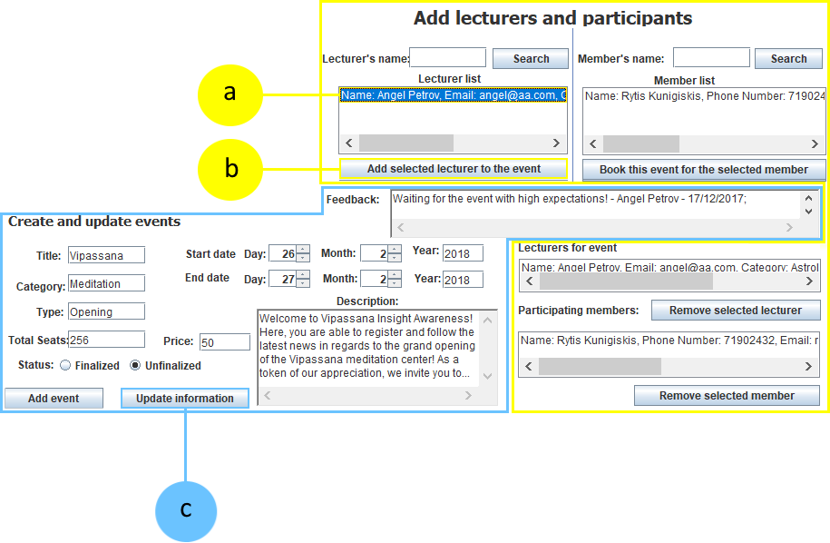

Upon successful input of information, you will be presented with the following message:



Information about the lecturer has now been updated and you may close this window.

**Assigning a member to an event:**

1. From the member list, select a desired member;
2. Click on the “Book this event for the selected member” button;



**Note:** Member will now be added in the “Lecturers for event” list;

1. Click on the “Update information” button in the “Create and update events” section;

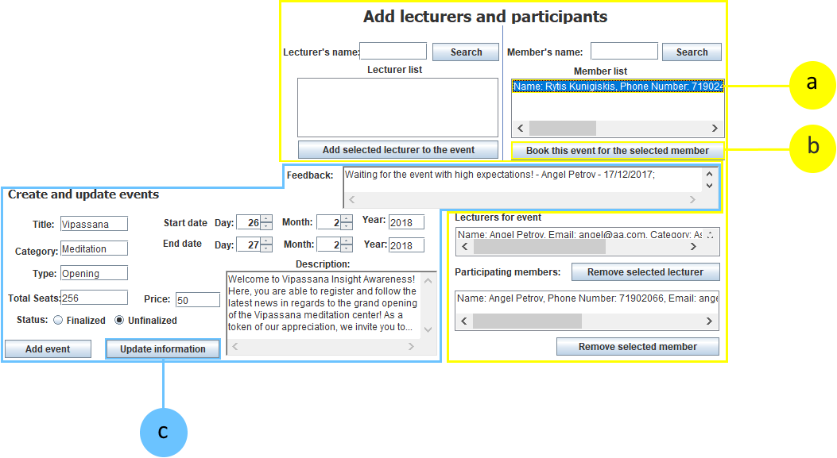

Upon successful input of information, you will be presented with the following message:



Information about the event has now been updated and you may close this window.

**Removing a lecturer from an event:**

1. From the “Lecturers for event”, select the desired lecturer that you would like to remove for the currently selected event;
2. Click on the “Remove selected lecturer”;
3. Click on the “Update information” button in the “Create and update events” section;

Upon successful input of information, you will be presented with the following message:



Information about the event has now been updated and you may close this window.

**Removing a member from an event:**

1. From the “Lecturers for event”, select the desired lecturer that you would like to remove for the currently selected event;
2. Click on the “Remove selected lecturer”;
3. Click on the “Update information” button in the “Create and update events” section;

Upon successful input of information, you will be presented with the following message:



Information about the event has now been updated and you may close this window.

Thank you for consulting with this manual! We hope that you enjoy using this software!

Version 1.06 – 18 / 12 / 2017

